|  |  |  |  |  |
| --- | --- | --- | --- | --- |
| |  | | --- | | Once upon a sign:Curriculum Guideline:The New Little Red Riding Hood | | Plot summaries:  Classic story: Little Red Riding Hood asks her mother if she can visit her sick grandmother. The mother agrees to the idea and packs a basket of food. On her way, Little Red Riding Hood meets a Wolf and mentions that she is on her way to visit her sick grandmother. The Wolf takes a shortcut and beats the girl to her grandmother's house. The Wolf eats the grandmother upon arrival and hides in her bed. The Little Red Riding Hood arrives at the house and finds the Wolf. The Wolf chases Little Red Riding Hood, and her screams alert a Woodsman. The woodsman kills the wolf, rescues Little Red Riding Hood, and rescues her grandmother by cutting open the wolf’s stomach.  Once Upon a Sign story: Set in New York City, Little Red crosses through Central Park to bring her grandmother cookies and milk. On the way she runs into the Park Ranger and Little Wolf. The Wolf beats her to Grandma’s house and gets into Grandma’s bed. Little Red is suspicious of the Wolf’s big eyes, ears and teeth. The Park Ranger rescues Little Red. It turns out Grandma and Little Wolf were playing a trick on Little Red, and Grandma was hiding. Everyone goes to Central Park to enjoy a picnic. | | |  | | --- | | Class time26-minute videoBasic Comprehension:10-30 minutes  * **Advanced Learners: Approximately 2 class periods (100 minutes) for video viewing, basic comprehension activities, preparation and performance.** | |



**Basic Comprehension Procedure**

1. Introduce Story, discuss original story learned as a child, prepare students for “new” (different) version.
2. Show the video. If there is time, show the video (or parts of the video) twice. While the video is replaying have students copy the signing to increase fluency.
3. Use Comprehension Questions to check for understanding.
   1. Use as a quiz after the video, collect and grade

OR

* 1. Discuss questions as a class--use think, pair, share strategy for full engagement (give students 2-3 minutes to consider which answer they think is correct, 2 minutes to discuss with a partner, choose a student to answer).

1. Compare the “new” version with the original version. Note similarities and differences, especially the ending and moral of the story.

Answer Key

1. B 6. B

2. C 7. A

3. A 8. B

4. B 9. A

5. C 10. C



**Advanced Learners Procedure**

1. Complete Basic Comprehension Procedures
2. Using the guidelines described below, allow students 20 – 30 minutes to prepare their presentation for the class.

**Advanced Signers Activity**



How does this version differ from the traditional Little Red Riding Hood? Act out and sign the traditional Little Red Riding Hood for your class.

**Once Upon A Sign**

**The New Little Red Riding Hood**

**Basic Comprehension Questions:**

1. **What is Little Red bringing Grandma?**

A. Fresh fruits and veggies

B. Cookies and milk

C. Coffee cake and tea

1. **How do Little Red’s mother and grandmother communicate?**

A. On the phone

B. By text

C. Video phone

1. **What does Little Red’s Grandma suggest Little Red’s mom do because she looks tired?**

A. Yoga and Meditation

B. Get more sleep

C. Eat healthy

1. **What is Little Red’s Grandma eating on her strict diet?**

A. Greens

B. Kale

C. Cookies

1. **Where does Little Red Live?**

A. In the Black Forest

B. By the Atlantic Ocean

C. In New York City

1. **Why does everybody call Little Red, “Little Red”?**

A. Red is her favorite color

B. She has a red scarf and red hair

C. That’s her name

1. **Who were the two strangers Little Red spoke to on her way to Grandma’s?**

A. The Park Ranger and Little Wolf

B. Little Wolf and a Business Man

C. The Park Ranger and a Policeman

1. **How does Little Red sign, “Are you still sick”?**

A. 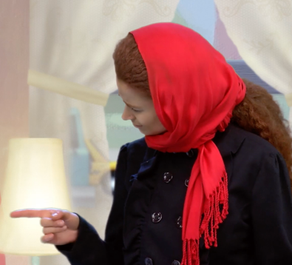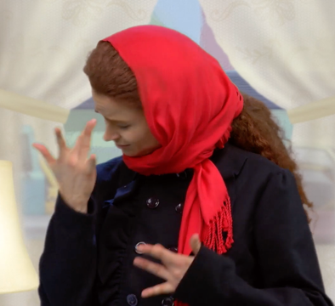

B. 

C. 

1. **What was Grandma doing when Little Red got to her house?**

A. Playing hide and seek

B. Little Wolf had eaten her

C. She was out doing yoga

**10. Who joins Little Red and Grandma for a picnic in the park?**

A. Little Wolf

B. The Park Ranger

C. Both Little Wolf and the Park Ranger

