|  |  |  |  |  |
| --- | --- | --- | --- | --- |
| |  | | --- | | Once upon a sign:Curriculum Guideline:The New Jack and the Beanstalk | | Plot summaries:  Classic story: A widow lives on a farm with her son, Jack. They realize they need to sell their old cow and use the money to buy seeds for their crops. Jack encounters an old man on his way to town and agrees on a trade. Three magical beans for Jack’s cow. Jack returns home to an angry mother and realizes he may have been fooled. He throws the beans outside and goes to sleep. The next morning, he wakes up to see a big beanstalk. Jack climbs up the beanstalk and arrives at a castle. At the castle, he discovers a giant. Jack climbs the beanstalk two more times. Each time he steals from the giant, first a goose that lays golden eggs, then a singing harp. On Jack’s last trip the giant wakes, chasing Jack. Jack returns to the ground and cuts the beanstalk and the giant falls to his death.  Once Upon a Sign story: Jack is a poor boy who lives in Los Angeles with his mother and siblings. One day his mother sends Jack to sell the family’s chickens to get food. On the way Jack meets a man who gives Jack three magic beans in exchange for the chickens. His angry mother throws the beans onto the garden. Over night the beans grow into a huge beanstalk and Jack climbs up. At the top he finds a castle where a giant and his wife live. The giant’s wife helps Jack hide. Jack steals the chicken who lays golden eggs, but is chased down the beanstalk by the giant. The giant falls off the beanstalk, and his life flashes before his eyes. The giant decides to change his ways, to become kind and stop his castle factory from polluting the skies of Los Angeles. | | |  | | --- | | Class time26-minute videoBasic Comprehension:10-30 minutes  * **Advanced Learners: Approximately 2 class periods (100 minutes) for video viewing, basic comprehension activities, preparation and performance.** | |



**Basic Comprehension Procedure**

1. Introduce Story, discuss original story learned as a child, prepare students for “new” (different) version.
2. Show the video. If there is time, show the video (or parts of the video) twice, while video is replaying have students copy the signing to increase fluency.
3. Use Comprehension Questions to check for understanding
   1. Use as a quiz after the video, collect and grade

OR

* 1. Discuss questions as a class--use think, pair, share strategy for full engagement (give students 2-3 minutes to consider which answer they think is correct, 2 minutes to discuss with a partner, choose a student to answer).

1. Compare the “new” version with the original version. Note similarities and differences, especially the ending and moral of the story.

Answer Key

1. B 6. B

2. A 7. C

3. C 8. A

4. A 9. B

5. C 10. C



**Advanced Learner Procedure**

1. Complete Basic Comprehension Procedures
2. Using the guidelines described below, allow students 20 – 30 minutes to prepare their presentation for the class.

**Advanced Signers Activity**



Use your imagination to create a new story using the “fun signs” included at the end of the story.

*Imagination, Eggs, Hungry, Gold, Food, Chicken, and Beanstalk*

Include all of the “fun signs” without any of the same characters or the same plot. Make sure you both act out and sign your story.

**Once Upon A Sign**

**The New Jack and the Beanstalk**

**Basic Comprehension Questions:**

1. **What is Jack selling?**

A. Beans

B. Chickens

C. Cows

1. **Where is Jack going to sell?**

A. The City

B. The Market

C. The Neighbors

1. **Jack compared what he was selling to what?**

A. Food

B. Money

C. Gold

1. **How does the man Jack meets change trash to gold?**

A. Recycling

B. Magic

C. Melting them down

1. **What does Jack get in trade?**

A. Money

B. Gold

C. Magic Beans

1. **What does Jack have to look through to see LA?**

A. Trees

B. Smog

C. Pollution

1. **What was in the Giant’s soup the previous night?**

A. Chicken

B. Americans

C. Several Englishmen

1. **What sign did the Giant use for “flashback”?**

A. 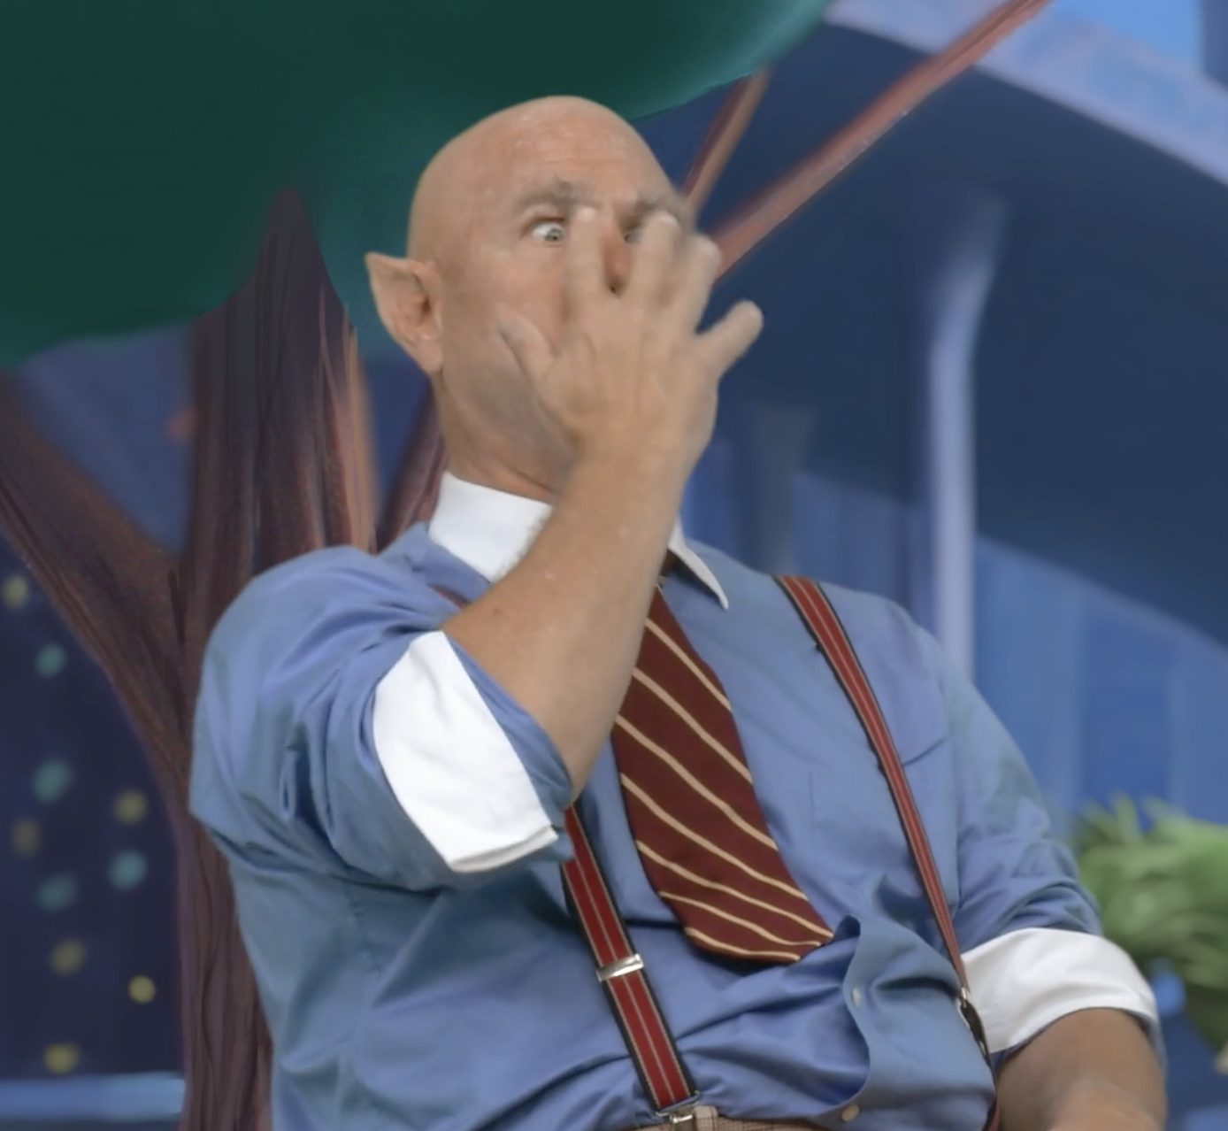

B. 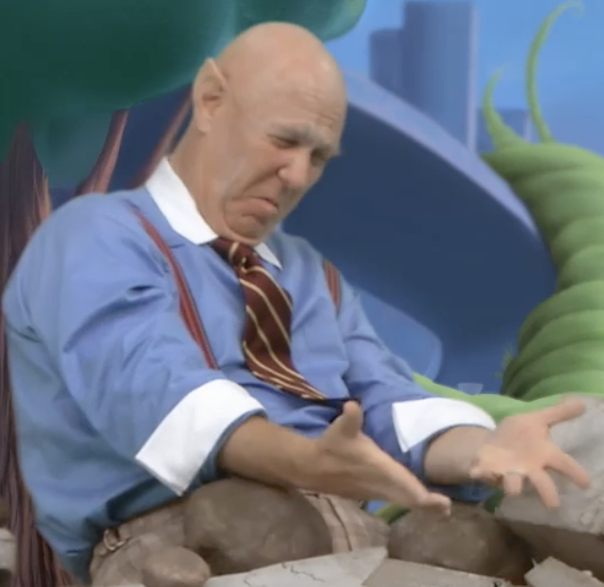

C. 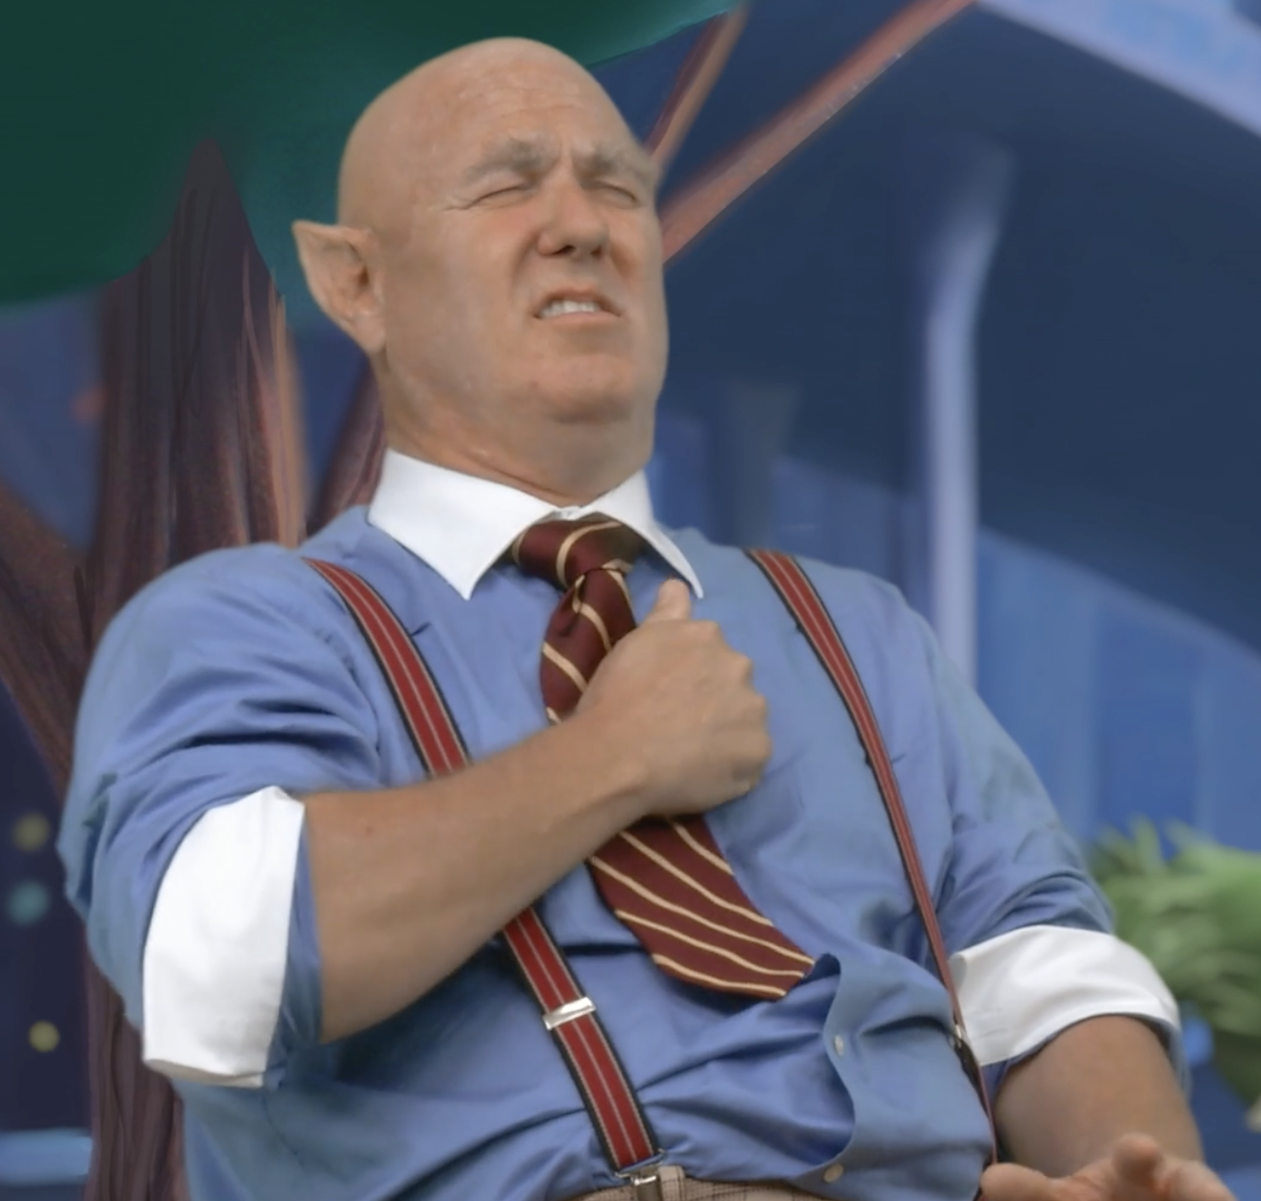

1. **What caused the pollution?**

A. Too many cars

B. The Giant’s Factory

C. Wildfires

**10. Why did the Giant change his attitude?**

A. The Sun came out

B. He was tired of being mean

C. His life flashed before his eyes

